Are there other related and/or competing standards? If so, list them and briefly explain how they differ from the standard you are analyzing.

Microsoft .NET programs run inside the Common Language Runtime (CLR), just as J2EE programs run inside the Java Virtual Machine (JVM). The .NET Framework adds a rich library of functionality to the CLR, considerably stronger than the additional capabilities J2EE brings to the JVM. In J2EE, even simple tasks become difficult. For example, EJB performance problems cause most programmers to use bimodal data access, which requires them to write twice as much code.

Because the .NET Framework is so rich, programmers will typically need to write significantly fewer lines of code than they will with J2EE. For example, one of J2EE’s most ardent supporters recently concluded that the most optimized Java Pet Store possible requires 14,004 lines of code under J2EE, but only 2,096 using the .NET Framework.

The total cost of a solution consists of how much money an enterprise spends to build and then deploy the application. In both cases, Microsoft .NET offers a significant advantage over J2EE.

When building a J2EE solution, programmers have a severely limited range of language choice, they can only use Java. On the other hand, the .NET Framework supports almost 30 languages.

Finally, because performance data indicates that J2EE solutions support fewer users than .NET solutions on comparable hardware, the J2EE solutions will generally require more of these more expensive servers. .NET solutions are simply less expensive to build, less expensive to deploy, and less expensive to maintain.

.NET

2. J2EE

J2EE short for Java 2 Platform Enterprise Edition. J2EE is a platform-independent, building distributed object-oriented enterprise systems. The J2EE platform consists of a set of services, APIs, and protocols that provide the functionality for developing multitier, Web-based applications. J2EE written by Java

Architecture

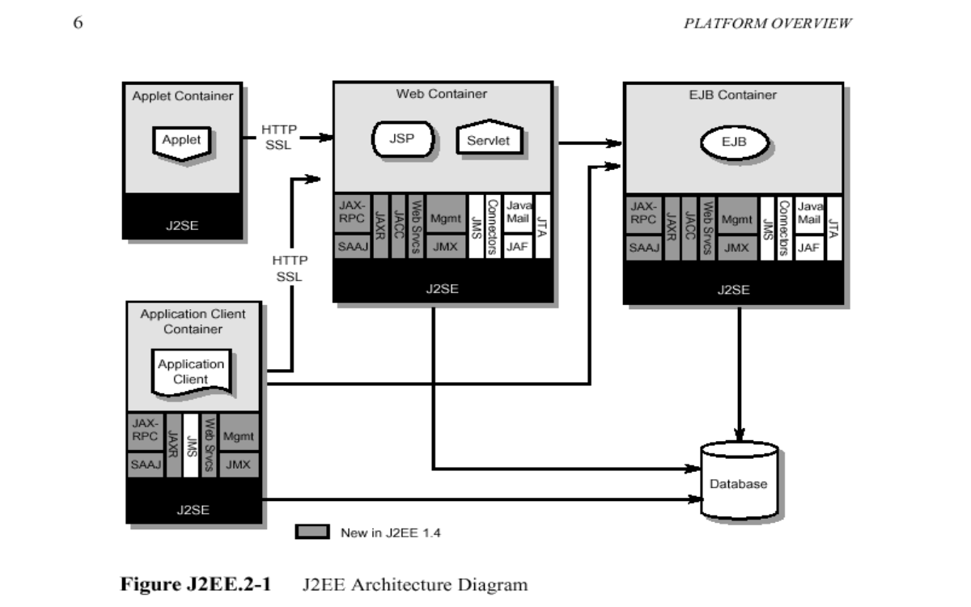

Source:

<http://en.wikipedia.org/wiki/.NET_Framework>

“Software Architecture in Practice” by Len Bass, 2003